Dara Abounorinejad & Rade Pilkinton

Professor Ananth Kalyanaraman

CptS 411

September 17, 2020

**Graphs of Send/Recv Data**

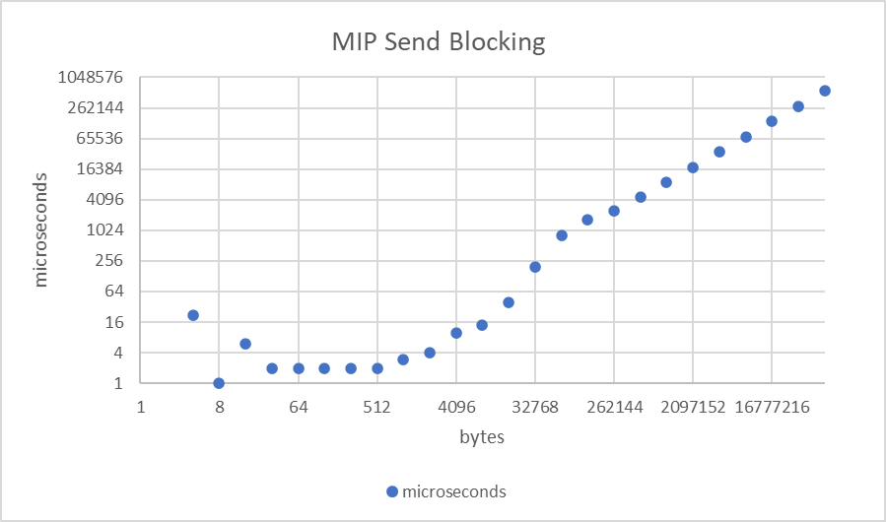

Slope after linear trend: 0.008396

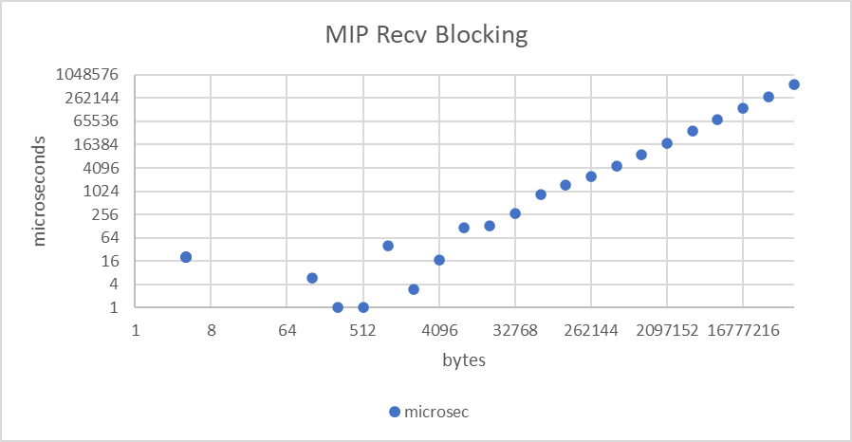

Slope after linear trend: 0.00849

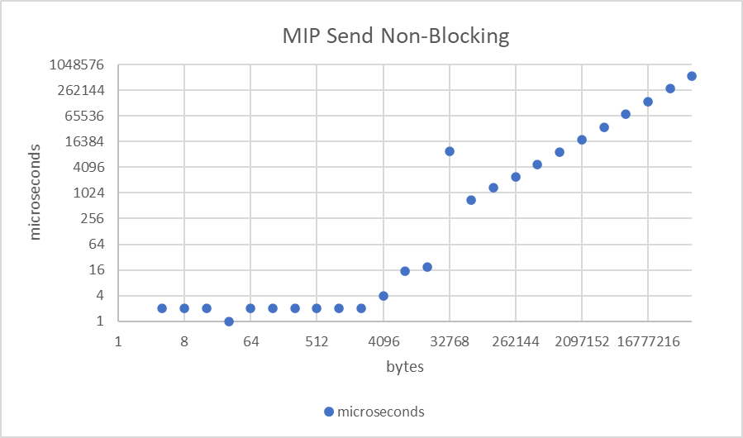

Slope after linear trend: 0.00847

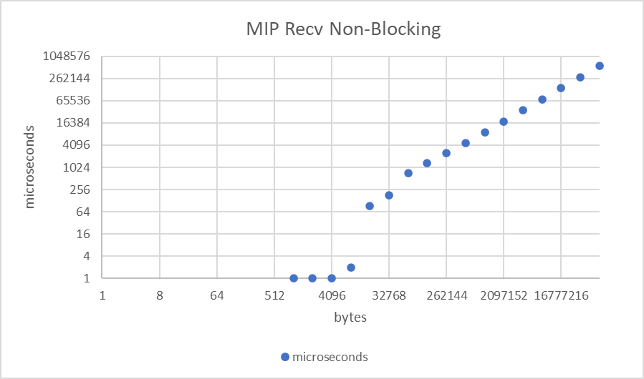

Slope after linear trend: 0.00848

**Aggregate Data**

**Latency: 22 microseconds**

**Bandwidth: 118.0595 bits per microsecond**

**Network Buffer Size: 65536 bytes**

For this project, we graphed the data in microseconds because the time it takes for small amounts of data to be is not even one millisecond. From the graphs, it can be deduced that the graphs begin to follow a linear patter at around 750 microseconds, so by averaging all the times before that point in all four datasets, we get a latency of about 22 microseconds. The slope of the graphs after their linear trends begin averages to about 0.00847, so the bandwidth, which is the inverse of that, is 118.0595 bytes per microsecond. The point where the graphs begin to follow a linear trend is at 65536 bytes, which we deduce to be the size of the network buffer, because we deduce it is at this point that the buffer needs to be flushed and repopulated before communication can continue.